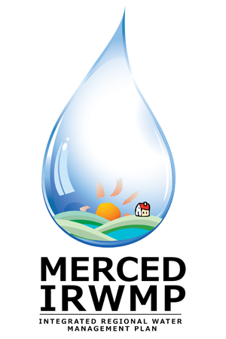

Merced Integrated Regional Water Management (IRWM) Plan
Regional Advisory Committee Meeting #3
Tuesday July 24, 2012
2:00 pm – 5:00 pm
The Sam Pipes Room
1st floor of the Civic Center (City Hall)
678 W. 18th Street
Merced, CA 95340

- Introductions and Overview 15 Min
- DWR Update 5 Min
- Approve Revised RAC Materials 10 Min
  - Notes from Meeting #2
  - Revised RAC Charter
- Preview Merced IRWM Website 10 Min
- Present Regional Water Balance 25 Min
- Review Project Schedule Drivers 10 Min
- Revise IRWM Plan Objectives 60 Min
  - Objectives Identified at Technical Workshops
  - Additional / Modified Objectives
  - Prioritization of Objectives
- Review Resource Management Strategies 15 Min
- Discuss Project Solicitation and Review Process 20 Min
- Identify Next Steps 5 Min
- Public Comment 5 Min

